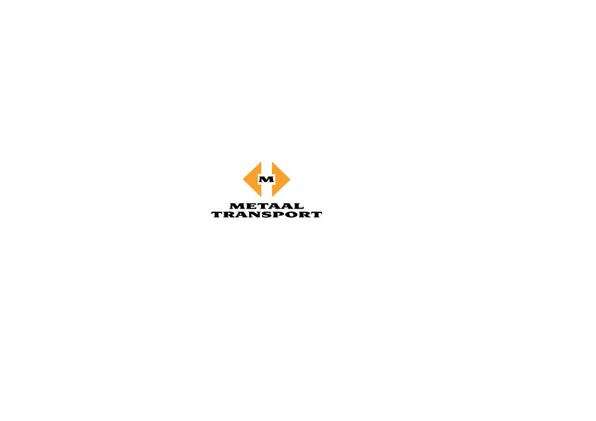
GENERAL CONDITIONS
- These LME Warehouse Delivery Out Procedures and Rates set out the general process effective as of 1 April 2024 and are valid until 31 March 2025. These conditions may be amended from time to time and are published on our website: www.metaaltransport.nl/conditions
- All transactions are under the Dutch Forwarding and Warehousing conditions which are available at www.metaaltransport.nl/conditions

  - Customers must pay the full amount of FOT charges and LME rent for cancelled warrants.
  - LME Rent will continue up to and including the date of material collection from LME warehouse.
- Drivers must sign the collection note.
- Drivers need to have strapping belts and anti-slipping mats for lasing and securing of materials.
*Metaal Transport reserves the right to not load materials in case of insufficient strapping and anti-slipping materials.

GENERAL OPENING HOURS
- Monday to Friday 7:30 – 16:00.
- Last vehicle check-in is at 14:30.
*The procedures are subject to LME rules and regulations as amended from time to time.

LME Delivery Out Charges Per Metric Ton:
Free on Truck (FOT) | Free in Container | Free in Barge | Free on Rail
33,00 € | 43,00 € | 45,00 € | 45,00 €
Excl. L/S/D | Excl. L/S/D | Excl. L/S/D | Excl. L/S/D
Excl. cobalt | Excl. cobalt | Excl. cobalt | Excl. cobalt
(L/S/D – Lashing/ Securing/ Dunnage)
*Charges basis according to actual gross weight of material delivered out
Free on Truck (FOT) | Free in Container | Free in Barge | Free on Rail
39,80 € | 47,75 € | 60,00 € | 60,00 €
Excl. L/S/D | Excl. L/S/D | Excl. L/S/D | Excl. L/S/D
For cobalt | For cobalt | For cobalt | For cobalt
(L/S/D – Lashing/ Securing/ Dunnage)
*Charges basis actual gross weight of material delivered out
Above Delivery Out Charges Cover:
- Free on Truck (FOT): Loading from in LME-warehouse on to truck.
*Not included: Documentation, Blocking, Lashing, Securing, and Dunnage.
- Free in Container: Charges from in LME-warehouse up to stuffed in container.
*Not included: Documentation, Blocking, Lashing, Securing, Dunnage, “loading on/off & from/to trailer” (if applicable).
à The metal owner is responsible for covering the expense of transporting such a container to/ from the warehouse's designated location.
- Free in Barge: Loading from in LME-warehouse in barge.
*Not included: Documentation, Blocking, Lashing, Securing, and Dunnage.
- Free on Rail: Loading from in LME-warehouse onto rail wagon.
*Not included: Documentation, Blocking, Lashing, Securing, and Dunnage.
LME Storage Rent Per Metric Ton Per Day In US $ Cents:
AA | CU | PB | NI | AL | SN | ZN | CO | STEEL
54 | 51 | 51 | 58 | 55 | 55 | 53 | 60 | 46

*LME rent basis standard LME lot weight for the applicable material.

ADDITIONAL CHARGES
Please note the following additional charges (if applicable)
Currency (€)
Metal re-warranting | 135,00 per warrant
Slot re-scheduling | 75,00 per unit
Splitting warrant administration fee | 40,00 per unit
Offering a detailed packing list after cancellation | 125,00 per warrant
Marking the warrant ID on each piece/bundle | 8,50 per tonne
LME eCOA Registration Fee | 9,50 per warrant
Admin fee | 35,00 per shipment
NOTICE OF DELIVERY OUT PROCEDURES
Delivery Procedures of LME Cancelled Lots:
For deliveries under Free on Truck (FOT), Free in Container, Free in Barge, and Free on Rail terms, bookings must be agreed upon before loading. Time and loading slots will be finalized during the booking process.
To ensure smooth operations, Metaal Transport B.V. requires the following information by no later than 11:00 on the working day prior to the collection day:
- Delivery Terms: Specify whether it's Free on Truck (FOT), Free in Container, Free in Barge, or Free on Rail.
- Time/Loading Slots: Indicate preferred time and loading slots, which will be confirmed during the booking process.
Please ensure timely submission of the above information to facilitate efficient logistics planning.
Free on Truck/ Container | - Transport company  - Truck/ trailer plate number  - Driver’s full name  - Drivers ID
Free in Barge | - Number of Barge  - Number of Barge crewmembers  - Vessel/ Barge nomination must be submitted no later than 5 working days  - Upon nomination, the agent must update us with ETA:  - Port berthing: 72 hours before arrival  - Barge terminal berthing: 48 hours before arrival  - Other locations: 24 hours before arrival  *Timely updates ensure smooth coordination
Free on Rail | - Railway company  - Waggon numbers and specifications/ payloads  - Loading instructions  - Securing instructions (if applicable)

